**Ideation Phase**

**Define the Problem Statements**

|  |  |
| --- | --- |
| Date | 26 JUNE2025 |
| Team ID | LTVIP2025TMID59973 |
| Project Name | Citizen AI-Intelligent Citizen Engagement Platform |
| Maximum Marks | 2 Marks |

**Customer Problem Statement Template:**

A customer problem statement is a clear, description of customer’s unmet need or challenge that a product or service aims to address. I t focuses on the customer’s perspective and helps teams understand the specific problem they are trying to solve , ensuring solutions are customer-centric and effective. Using a customer problem statement has many benefits such as it focuses on customer needs, improves clarity, increases efficiency, enables better solutions, facilitates empathy.

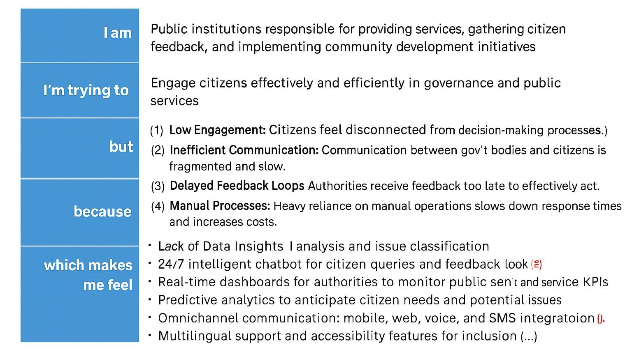

**Example:**

|  |  |  |  |  |  |
| --- | --- | --- | --- | --- | --- |
| **Problem Statement (PS)** | **I am (Customer)** | **I’m trying to** | **But** | **Because** | **Which makes me feel** |
| PS-1 | Young professional | Build my financial portfolio | Struggle to understand complex investment options and find the time to manage their investments | They lack financial literacy and have limited time | Stressed and uncertain about their financial future |
| PS-2 | Traveller | Book flights on phone | It takes a long time | The website is not that much responsive | Exhausted |